RASDR Users Manual

supporting

Software Defined Receiver for Radio Astronomy

RASDR Users Manual

supporting

Software Defined Receiver for Radio Astronomy

Table of Contents

List of Figures 5

List of Tables 7

Forward 8

Abstract 8

1) README First 9

2) RASDR goals and description 9

a) A Software-Defined Receiver for Amateur Radio Astronomers 9

b) The RASDR Community: Developer’s group and User’s group 9

c) Power and Data Transfer Considerations 10

d) Operation of RASDR in Various Radio Astronomy Bands 11

3) The RASDR Software Defined Receiver (hardware) 13

a) Specifications 14

4) Startup Guide for a RASDR Observatory 15

5) RASDR Hardware Basics 17

a) MyriadRF hardware 17

Layout 17

Input/output 18

Configuration [Advanced users] 19

b) DigiRED hardware 20

Input/output 20

USB Control 21

LED indicators 21

Configuration 23

Loading new firmware 23

6) RASDRViewer and RASDR Software Basics 24

a) Introduction 24

b) Installing RASDRviewer 25

c) Architecture 25

d) Graphical User Interface 26

e) FFT Output to Disk 28

7) Basic Radio Astronomy with RASDR (discussion and examples) 30

a) Hydrogen HI Spectroscopy. L-band (1420 MHz) 30

b) System Gain Considerations 32

8) Postprocessing 34

9) Basic Radio Astronomy below RASDR design frequency 34

a) Radio Astronomy in the VHF band (80-190 MHz) 34

b) Band-Extension Spectroscopy Testing and application to wide-band VHF monitoring 38

c) Using the VHF converter to access the NRAO 40’ dish 38

d) RASDR Spectroscopy in HF band (2-80 MHz) 38

10) Operating RASDR beyond the limits: SETI and weak signals 41

11) Appendices 43

a) RASDR Drivers 43

https://github.com/myriadrf/RASDR/blob/master/DigiRED/driver/digired-windows.zip?raw=true 43

b) Troubleshooting 43

c) General and Frequently-Asked Questions (FAQs) 44

d) RASDR & Myriad RF connectors details 46

X1 Connector - DigiRed to Myriad 46

X2 Connector - FX3 JTAG interface 49

X3 Connector - PPS / Clck-ext and GPIO Connector 50

e) X7 Connector - Input Reference Frequency Provision 50

12) References 52

13) Index 56

### List of Figures

Figure 1 RASDR functional overview. 13

Figure 2 Typical RASDR observatory suitable for H1 observations 15

Figure 3 The core hardware RASDR package consists of two circuit boards. 17

Figure 4. The Myriad-RF board was manufactured in several versions. SARA boards produced in 2014 are matched to the DigiRED board. Earlier versions may require addition of a simple dongle with extra resistors. 17

Figure 5 The MyriadRF board is the RF section of RASDR, and interfaces directly to DigiRED via the X3 connector . The SMA connectors are for transmit and receive sections. Only receive operations are currently supported by the RASDR team. 19

Figure 6 DigiRED connection descriptions. 20

Figure 7 Some Konig© (L) and Inatech© PCIE cards provide USB2/USB3 connectivity to PC desktop computers. 21

Figure 8 LED Indicators on digiRED board. 22

Figure 9 (L) shows Rx and Tx LED indicators and (R) shows location of LED D9. 22

Figure 10 GUI Start window of the RASDRViewer application 26

Figure 11 Chip parameter settings 27

Figure 12 ADC Power input 27

Figure 13 FFT Recording configuration 29

Figure 14 Initial choices of RASDR2 control parameters for comparison with typical SpectraCyber results, were not the final selection.. Better results were obtained by choosing minimum BW for this narrow spectral region. See text for choice of values shown in red. 31

Figure 15 The importance of spectral averaging is shown with processing of 99 frames (left) and 998 frames (right). Control settings were as shown in Figure 14. USB2 connectivity was used to an IBM laptop running WinXP, and using a USB2 interface. 31

Figure 16 This figure is the difference file using the 99 file average and the 998 file average shown in Figure 15The 2dB noise component from Figure 15 (left) is all that remains. The common feature is removed, and the same method can be used to remove system noise or select for ‘genuine’ signals. 32

Figure 17 Example system configuration for H1 detection. RASDR hardware is outlined in blue. 32

Figure 18. Block functions of the VHF converter show conversion of 80-190MHz VHF signals into the RASDR2 input band acceptance range. 35

Figure 19 Completed VHF converter used with RASDR2. Input is via the coax cable while the output is via the SMA connector shown on the upper right. 36

Figure 20 Commercial FM band. The antenna was a random wire about 2m long, connected to theVHF upconverter, then to RASDR2. The red marker was added on the RASDR2 display to denote a local FM station broadcasting at 102.113 MHz. 37

Figure 21 RASDR2 internal narrow-banding was chosen to select a region of interest. In practice, narrow banding is useful to reject unwanted outlying signals (noise). 37

Figure 22 The complete RASDR2 video output with VHF input shows the input signal stream as digitized (I and Q values); the I vsQ plot (a circle if there is a single coherent source, the FFT spectral display with markers if selected, digitization and internal gain settings, and a power vs. time plot. The ratty power vs. time plot on the lower right shows the result of moving the antenna. 38

Figure 23 Functionality of the Nooelec upconverter is as shown. The RF input is nominally specified 0-65 MHz and the measured performance covers in the range 2-66 MHz. Filter functions are as described with reference to Figure 4. 39

Figure 24 Two upconversion stages are shown here, which provide for conversion of the 2-66MHz portion of the HF band to the 402-466 MHz band prior to processing with RASDR2. The Nooelec converter is on the lower left while the VHF converter described earlier appears at the upper right. 40

Figure 25 Noisy 5.5 MHz section of the HF band centered on 15 MHz. This measurement was made with an electrically short antenna and no preamplifier. It shows various sources of noise including some from the Nooelec upconverter. This experiment suggest the importance of a decent antenna, more preamplification and background subtraction. 40

Figure 26 The Kepler mission search zone considers a tiny fraction of our galaxy. 41

Figure 27 JTAG conector. 50

Figure 28 LED D9 is illuminated green to denote frequency lock. 50

### List of Tables

Table 1. FCC band plan from 3kHz to 30GHz. 11

Table 2 Candidate radio astronomy research bands. Bands shown in and above HF are designated. The band shown as VLF has been proposed for radio astronomy under special conditions (Fields, et al., 2011) 12

Table 3 Basic RASDR specifications are focused on receive operations from app. 0.4-4 GHz. 14

Table 4 Example startup procedure for new RASDR observatory 16

Table 5 MyriadRF specifications. 18

Table 6. Myriad-RF Board Connector Assignments 19

Table 7 DigiRED board connectors and switches. 20

Table 8 DigiRED LED status indicators. 23

Table 9. Examples of system gain from components for monitoring H1 signals. 33

Table 10 X3 connector pin description 48

### Foreword

This User’s Guide is an early version, almost a draft copy, so as you discover errors or have suggestions, please communicate them to [RASDRapplications@radio-astronomy.org](mailto:RASDRapplications@radio-astronomy.org). Thanks to all on the RASDR team who contributed.

Thanks also to SARA for supporting us as we migrated through three radically hardware approaches and a host of design and production pains. **This is a community open source effort** **for the benefit of SARA members. We expect that the fruits of the all-volunteer labor will be useful to the amateur radio astronomy, educational, and scientific communities**. The RASDR hardware will be available non-profit to SARA members and others; however, if anyone wants to take our hardware designs and produce them at a lower price for the benefit of everyone, then we will be delighted. The radio astronomy community will benefit.

We’re maintaining RASDR software and intend to keep adding features so as others have time to contribute, please contact us via the SARA site or the Users Group and you’ll receive a response.

### License

Unless otherwise specified, all software source files are licensed using the GNU General Public License Version 2. To read details of the license please visit <http://www.gnu.org/licenses>. All hardware related designs, source artifacts and documentation are licensed under the “Creative Commons Attribution 3.0 Unported”. To read the details of the license please visit <http://creativecommons.org/licenses/by/3.0/legalcode>.

### Abstract

RASDR is a software-defined receiver (SDR) for radio astronomy[1]. The device consists of two high-density circuit boards, separated by analog and digital operations. The analog board contains a wide-band radio-frequency (RF) to baseband transceiver used for femtocell[2][3] applications. The digital board is a function control and data interface to a computer via universal serial bus (USB). The RASDRViewer software runs in a Windows environment and performs receiver control, fast-Fourier transform (FFT) analysis and spectrum averaging, power monitoring and data collection. The user is responsible for supplying an antenna, preamplifier, band pass filter, optional up conversion or system control devices, and external frequency/time reference signals.

# README First

Please read Chapter 2 and Chapter 4 before starting to connect and use your RASDR. Please join SARA[1] and the User’s group. The SARA RASDR pages[4][1] provide news and new information. The RASDR User’s Group[5] is a good resource to obtain community support and help. The development sites [4][6] are available for people who wish to help contribute or to use the design for their own purposes.

Users having general questions should post them to one of the User sites. Specific questions may be sent to members of the RASDR team at the following addresses:

Software issues:  
Contact [RASDRviewer@radio-astronomy.org](mailto:RASDRviewer@radio-astronomy.org)   
  
Hardware issues:  
Contact [RASDRhardware@radio-astronomy.org](mailto:RASDRhardware@radio-astronomy.org)    
  
Application issues:  
Contact [RASDRapplications@radio-astronomy.org](mailto:RASDRapplications@radio-astronomy.org)

# RASDR goals and description

This section highlights some of the goals of the RASDR project.

## A Software-Defined Receiver for Amateur Radio Astronomers

An SDR that is optimized for radio astronomy, applicable to a wide variety of SARA projects, includes a front end receiver and a software-driven desktop computer back end[4][7]. The receiver uses a computer chip containing the entire RF digital receiver chain designated LMS6002D [8][9]. The back end computer controls the front end and enables the user to control receiver functions, display signals and perform analysis functions (averaging, computation of spectrograms, determination of power time-spectrum, and generating output files).

Signal processing permits dealing with low signal-to-noise ratio (S/N) information, and presents data as spectral plots and data files. RASDRviewer software [10][12] for the Windows OS, performs parameter optimizations, user control, spectra output, power characterization and output data formatting via a Graphical User Interface (GUI).

This design evolution is based on the need to have widest possible data pipeline speed for radio astronomy applications, and to make this available to SARA members at cost to produce [11].

## The RASDR Community: Developer’s group and User’s group

It is recommended that the user begin by becoming a member of SARA [13]

There is a tab for RASDR at the top and a graphic for the RASDR open source history on the right side of that page.

The RASDRviewer program sets up the RASDR2 hardware for safe operation as a powerful radio astronomy receiver. Please do not attempt to exercise any of the disabled transmit functions, as these functions are unsupported and may produce receiver spurs, higher current drain and higher operating temperatures.

RASDR2 edge connectors should not be abused -- mechanical strain must be minimized. Switching power supplies can contribute electrical noise and should be only used with caution. If RASDR is installed in a box, heat sinking or cooling may be advised. The thermal transfer characteristics of any enclosure must be such to radiate the heat into the environment outside the box.

Myriad has produced two versions of the myriadRF board. Components obtained through the RASDR Users Group will have compatibility between SARA myriadRF and SARA DigiRED boards.

## Power and Data Transfer Considerations

RASDR has been powered in several different modes. Production RASDR units operate with less noise when operated from a single external low-noise power supply with the included ferrite shield. They are powered from a dedicated external connector.

Earlier Beta-test versions of RASDR2 operate from a single USB3 power source (power hub or externally-powered adaptor) or from two independent USB2 power sources. The use of two independent USB2 or USB3 sources can minimize current density in the micro connectors, plus may stabilize the power feed in noisy conditions. An unregulated USB3 “charging” port should not be used, since this may introduce reverse current flow in other USB-connected components.

As stated above, new (2015) RASDR production units use an external power supply, and are not powered from the USB2 or USB3 connectors. Voltage may still be provided on the USB connectors, but power will not be drawn. Data are routed through the ‘receive’ USB3 connector, located at the end of the board with the two SMA connectors. Please use RASDRviewer for control. If RASDRviewer is not used then there is a chance that transmit functions may not be suppressed and it will be most important that the transmit SMA connector is terminated with a 50 ohm terminator to minimize RF noise. Data transfer rates are faster when a USB3 superspeed connection is used. A USB2 connection will operate with lower bandwidth. Some USB3 adapter chipsets function better than others so if you want to choose a USB3 adapter, please experiment a bit or request suggestions from the Users Group.

## Operation of RASDR in Various Radio Astronomy Bands

The FCC spectral designations from 3kHz to 30 GHz [14] are shown in Table 1:

|  |  |  |  |
| --- | --- | --- | --- |
| **Band Number** | **Symbol** | **Frequency Range** | **Wavelength Range** |
| **4** | [**VLF**](http://en.wikipedia.org/wiki/Very_low_frequency) | **3 to 30 kHz** | **10 to 100 km** |
| **5** | [**LF**](http://en.wikipedia.org/wiki/Low_frequency) | **30 to 300 kHz** | **1 to 10 km** |
| **6** | [**MF**](http://en.wikipedia.org/wiki/Medium_frequency) | **300 to 3000 kHz** | **100 to 1000 m** |
| **7** | [**HF**](http://en.wikipedia.org/wiki/High_frequency) | **3 to 30 MHz** | **10 to 100 m** |
| **8** | [**VHF**](http://en.wikipedia.org/wiki/Very_high_frequency) | **30 to 300 MHz** | **1 to 10 m** |
| **9** | [**UHF**](http://en.wikipedia.org/wiki/Ultra_high_frequency) | **300 to 3000 MHz** | **10 to 100 cm** |
| **10** | [**SHF**](http://en.wikipedia.org/wiki/Super_high_frequency) | **3 to 30 GHz** | **1 to 10 cm** |

Table 1. FCC band plan from 3kHz to 30GHz.

Development of these bands for radio astronomy research is shown in the Table 2. It is taken from various sources and contains comments by the authors. The Jovian kilometric band is not often considered, but it has been observed by Voyager and other space probes, and may be a valid radio astronomy band from earth under certain circumstances.[15][16]. RASDR, along with ancillary equipment discussed in this Guide, has been used from 2MHz-4GHz.

RASDR2 operates in bands 9-10 (up to 4 GHz), but with additional components the coverage may be considerably extended, as will be discussed beginning on page .



Table 2 Candidate radio astronomy research bands. Bands shown in and above HF are designated. The band shown as VLF has been proposed for radio astronomy under special conditions [17]

# The RASDR Software Defined Receiver

RASDR consists of a Myriad RF board (RF Transceiver) and a DigiRED board (clock distribution and USB interface). The RASDR functional overview is shown in

Figure 1. Note that RASDR does not include an antenna, LNA, secondary amplification, external frequency reference, computer, etc. Figure 2 shows the hardware packaged into a metal case.

RASDR is a versatile instrument, but the user must tailor it to specific applications by including the necessary supporting components to build his observing system.

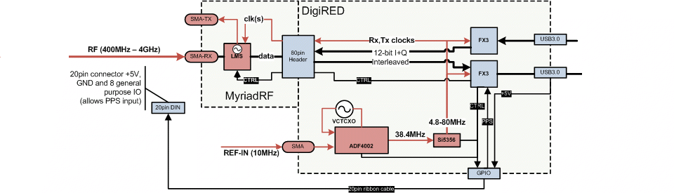

**8 pin connector**

+5V, GND input

PPS input

4 GPIO input/output

Figure RASDR functional overview.

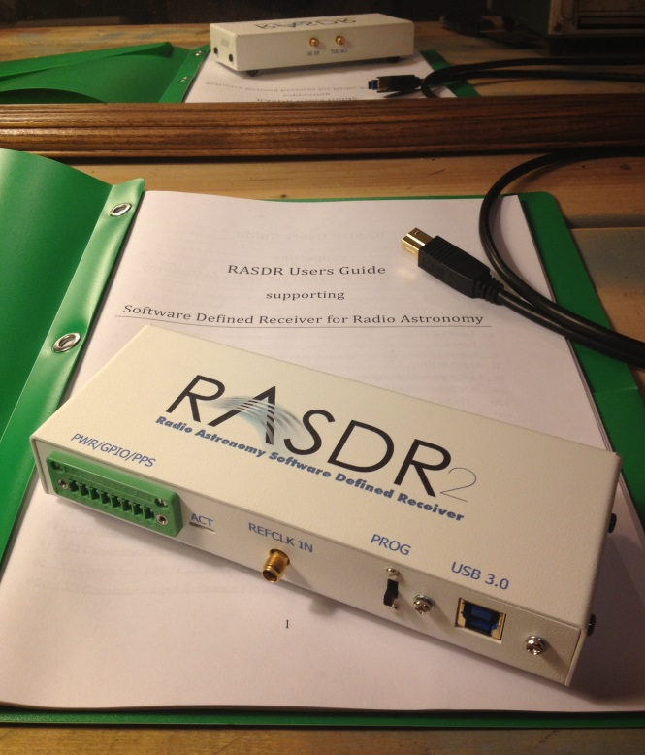

Figure 2 RASDR mounted in case

## Specifications

Basic RASDR specifications are presented in Table 3:

|  |  |
| --- | --- |
| Transceiver chipset | Lime Microsystems LMS6002D |
| RF Bandwidth (BW) | 300 MHz to 3800 MHz |
| ADC Resolution | 12 bits recorded in 16bit samples |
| Sampling Rate | 30 MHz I & Q (depends on PC and USB standard used) |
| Band pass filter BW | 1.5MHz to 28 MHz in 16 discrete steps |
| External Reference Clock Input | 10 MHz sine (see p.50) |
| 1 PPS Input | Yes through GPIO pin (Future firmware update) |
| RF/REF connectors | SMA female, 50ohm |
| PC connectors | USB 2.0 or 3.0 |
| Input Voltage | 5V Delivered through USB connector (beta units) or dedicated external connector (production units) |
| Dimensions | 70mm x 70mm x 32mm (2.75" x 2.75" x 1.25") |
| Mazimum internal RF gain | 61 dB |

Table 3 Basic RASDR specifications are focused on receive operations from app. 0.4-4 GHz.

# Startup Guide for a RASDR Observatory

Each radio observatory is different. Most amateur radio astronomers begin simply, monitoring the sun or Jupiter with a long wire antenna, or a dual-dipole antenna. RASDR may be used with block RF converters, depending on the spectral region of interest, and because if its versatility, finds usefulness in many observing projects. Some options are covered in this guide, while others may be found in the SARA archives (Journal and Proceedings).

A typical RASDR observatory for operation in the 300-3800 MHz spectral region, including hydrogen electron spin-flip (H1) signals is shown in Figure 3.

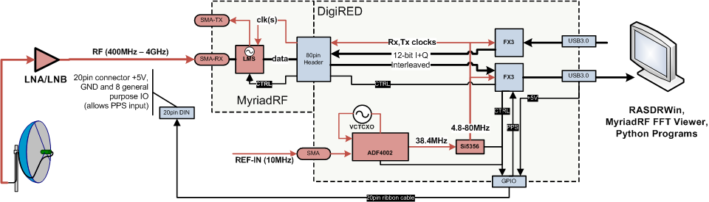

**BANDPASS FILTER**

**8 pin connector**

+5V, GND input

PPS input

4 GPIO input/output

Figure 3 Typical RASDR observatory suitable for H1 observations

System startup has two goals – protection of equipment and validation of performance. These are summarized in Table 4:

|  |
| --- |
| * Mentoring is important. SARA members are often willing to mentor new astronomers – contact SARA[13] if you have questions. Prepare a sheltered, protected area and install system components. |
| * Provide safe, grounded electrical power. |
| * Test and approve power supplies for proper DC levels and minimal AC or line noise. |
| * Connect and validate operation of RASDR/computer with no antenna connection. |
| * Verify that there is no DC on the RASDR input (especially if a bias-T is used to provide power to the preamplifier). |
| * Connect antenna/preamp output to RASDR and perform function tests with an unpowered preamp. RASDR should detect interference signals from local 400-425MHz, TV, WiFi, etc. |
| * Provide power to preamp and observe increase in signal, measured by RASDR. |
| * Test with noise source, or with antenna pointed at dark sky, vs. at building/trees/hand etc. |
| * Observe available sources (sun, hydrogen clouds in our galaxy, artificial sources, etc.). |

Table 4 Example startup procedure for new RASDR observatory

The above reference to the antenna suggests its importance. Antennas have different forms and must fit the frequency being monitored, the experimenter’s budget, and the available space. The intricacies of antenna selection[1] lie beyond the scope of this text but the SARA literature (Journals and Proceedings) can be very helpful.

Antennas can be built at low cost. Especially for frequencies below 1 GHz, the Radio Amateur’s Handbook[18] can be useful. For Jovian monitoring near 20 MHz, a dual-dipole antenna is attractive[19].

Should interfering signal prove difficult, an RF filter may be used either ahead of the LNA, or between the LNA and RASDR. Usually the latter is a better starting point.

## Installation of Device Driver

To begin, download the RASDR software distribution or at least the ‘driver.zip’ file from the [rasdr.org](http://rasdr.org/) website. Unpack the files and take note of the location, you will need it when you connect the RASDR receiver to your computer.

Ensure that your RASDR receiver is set to ‘RUN’ or that it has the jumper fitted onto the J2 connector of the DigiRED board. Connect the USB cable between the RASDR receiver and the desired USB port on your computer. You may use either a USB2.0 or USB3.0 port, although correct operation of RASDR for a USB3.0 requires a modern multi-core computer and greater than 4GB of system memory.

You will then go through a series of steps to associate the device driver with the RASDR receiver, as shown in the series of screenshots, x through x. The following procedure should be followed:

Connect the RASDR receiver USB port to the desired USB port on your computer.

For USB3.0, selecting the right port may be a challenge as some laptops provide only limited power output. In this case, you will see a message such as figure x.

You may see a message such as Figure 4. That is OK. You will update the device driver in the next step.

Start the Windows Device Manager. You may need to provide an administrator password. Select the ‘DigiRed_RX’ device, and choose ‘Update Driver Software…’ as shown in Figure 5.

Choose ‘Browse my computer…’ and navigate to the folder ‘win7’ if you are using Windows 7 (or ‘wxp’ if you are running on Windows XP) from the software distribution folder, ‘driver/’.

Ensure that ‘Include subfolders’ is checked, and press ‘Next’

Observe that the ‘RASDR Radio Astronomy SDR RX Interface’ is successfully installed, as shown in Figure 6.

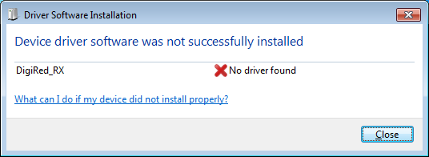

Figure 4 - RASDR inserted prior to driver update

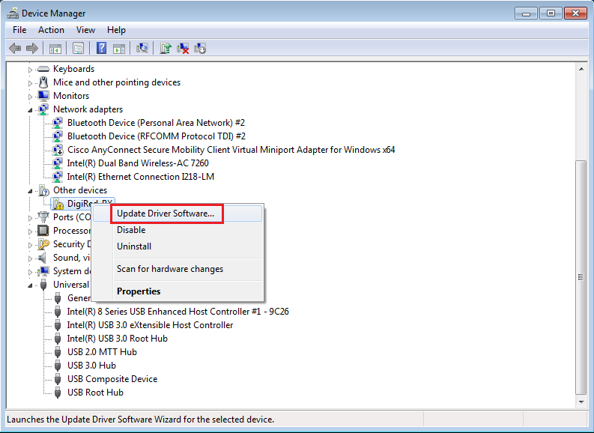

Figure 5 - Choose Device Manager and Update Driver Software

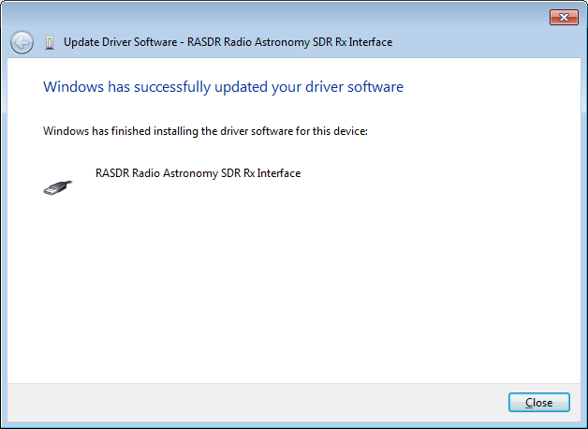

Figure 6 - RASDR Driver successful install

# RASDR Hardware Basics

As can be seen from the figure below, the core hardware RASDR package consists of two main boards, the Myriad RF and DigiRed boards.

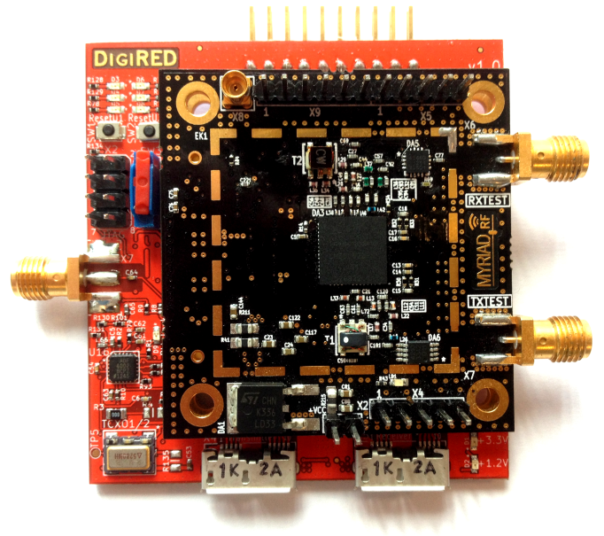

Figure 7 The core hardware RASDR package consists of two circuit boards.

## MyriadRF hardware

### Layout

RASDR uses the MyriadRF board[20] for RF digitations and front-end processing.

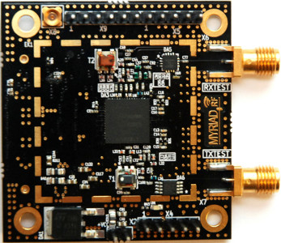

Figure 8. The Myriad-RF board was manufactured in several versions. SARA boards produced in 2014 are matched to the DigiRED board. Earlier versions may require addition of a simple dongle with extra resistors.

Shown above in Figure 4 the Myriad–RF 1 board is a multi-band, multi-standard RF module, based on the state of the art [LMS6002D](http://www.limemicro.com/lms6002d.php) transceiver IC by Lime Microsystems. It has one RF broadband output, one RF broadband input with digital baseband interface, established via standard connector [FX10A-80P](http://www.hirose.co.jp/cataloge_hp/e57000028.pdf). The board also provides the user with pin headers for power supply, reference clock, analog I/Q input/output and SPI interface connections. It contains everything needed for it to be connected to baseband (BB) chipsets, FPGAs or to run in an standalone mode.

Specifications are as shown in Table 5:

|  |  |
| --- | --- |
| **Item** | **Specification** |
| Transceiver | Lime Micro LMS6002D |
| RF Bandwidth (BW) | 300 MHz to 3800 MHz |
| Baseband BW | Programmable (16 selections); 0.75 – 14 MHz, Bypass mode |
| RF Module Control | Via SPI interface via DigiRed |
| Reference Clock frequency | 23 – 41 MHz (10 MHz only for external Reference unless specific frequencies are programmed.) |
| Input Voltage | 5 V(recommended).  The Myriad–RF 1 board is powered through the RASDR USB cable. |
| Dimensions | 5.5x5.5 cm |

Table 5 MyriadRF specifications.

### ****Input/output****

Figure 5 and Table 6 below provide key Input/Output configurations, connector assignments and descriptions. The analog differential IQ interface is available on Myriad-RF board and provided via X3 and X4 connectors. X6 and X7 are the RF connectors for receive input and transmitter output, clearly marked in the picture. The front end switches are configurable for selecting Receiver inputs and Transmitter outputs via GPIO’s which in turn can be controlled via the X3 connector.

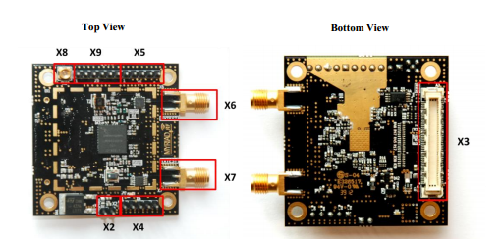

Figure The MyriadRF board is the RF section of RASDR, and interfaces directly to DigiRED via the X3 connector . The SMA connectors are for transmit and receive sections. Only receive operations are currently supported by the RASDR team.

|  |  |  |
| --- | --- | --- |
| **Connector** | **Name** | **Description** |
| X2 | +5 V supply | External +5 V supply. Supplied via DigiRed |
| X3 | Digital I/O | The FX10A-80P is a standard connector used to interface the RF board directly to interface board or any other baseband board. Used by DigiRed. For details see appendix e. |
| X4 | TX  Analog I/Q | Connector used to supply Transmit analog I/Q signals. Not usable on RASDR2 without hardware change. |
| X5 | RX  Analog I/Q | Connector used to measure Receive analog I/Q signals. Not usable on RASDR2 without hardware change. |
| X6 | RXTEST | SMA connector provides connection to low band or high band RX input. |
| X7 | TXTEST | SMA connector that provides connection to low band or high band TX output. Not supported by the RASDR2. |
| X8 | Ext – CLK | Connector used to supply PLL clock externally. Use external clock on DigiRed connector. |
| X9 | Ext – SPI | Connector used to control LMS6002DFN SPI registers externally. SPI register are controlled via X3 connector through DigiRed board. |

Table 6. Myriad-RF Board Connector Assignments

### ****Configuration [Advanced users]****

The MyriadRF board can be configured to a high level of detail through the RASDRViewer software configuration utility via the menu. This contains the Lime Micro Systems (LMS) configuration utility that comes with the Myriad RF board[21]. Note however, that for normal users this is not needed as the main GUI takes care of all the settings needed to operate the receiver for most use cases.

## DigiRED hardware

### Input/output

Figure 10 DigiRED connection descriptions.

The following table describes the digiRED board connectors shown in the figure above.

|  |  |  |
| --- | --- | --- |
| **Connector** | **Name** | **Description** |
| X1 | Myriad RF board connector | The FX10A-80P is a standard connector used to interface the Myriad-RF board directly to a base band board. See appendix e for more details. |
| X2 | JTAG connector | Standard five-pin JTAG interface to connect to a JTAG debugger in FX3 USB microcontroller. See appendix e for more details. |
| X3 | GPIO connector | Connection to free FX3 USB microcontroller GPIOs, for more details see the next sections. See appendix e for more details. |
| X4 | TX USB | USB2/3 interface connection for TX path. |
| X5 | RX USB | USB2/3 interface connection for RX path. |
| X7 | SMA female | 10 MHz Reference clock input for ADF4002 to lock the external clock from test equipment with DigiRED board clock. |
| J1 | TX Flash | This connector enables TX uC to load the firmware at startup.  If firmware is already loaded, this pins should be shorted (jumper in place). |
| J2 | RX Flash | This connector enables RX uC to load the firmware at startup.  If firmware is already loaded, this pins should be shorted (jumper in place). |

Table 7 DigiRED board connectors and switches.

### USB Control

Rx control and datastreaming is performed through USB3.0 Rx connector which is also backwards compatible with USB2.0.

A computer with USB2 connectivity can accept RASDR data using a USB2 cable; however, the bandwidth (BW) will be limited, probably to 10 Msamples/s. A USB2/USB3 adaptor can be added to permit USB3 input, but not all such adaptors are equivalent, since different chipsets are used by different vendors.

For desktop PCs, good results have been obtained with the Konig Electronic CMP-PCIE2USB3 pci express card with the the NEC/Renesas UPD720202 chipset, available from Amazon for about $36 (2015 price).

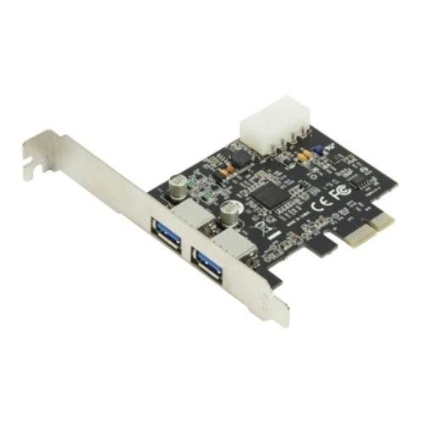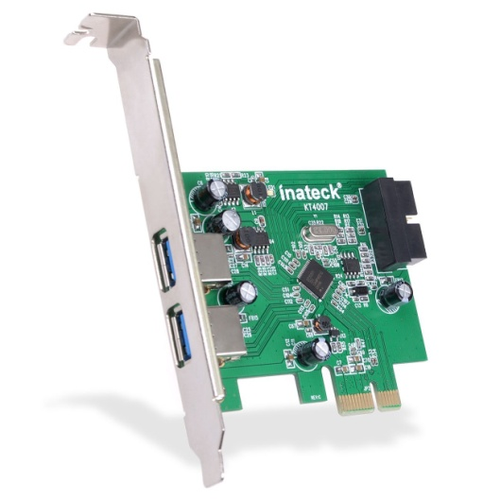

Figure 11 Some Konig© (L) and Inatech© PCIE cards provide USB2/USB3 connectivity to PC desktop computers.

Good results were also obtained with an Inateck KT4007 which uses the NEC D720201 chipset. The Konig and Inateck boards are shown in Figure 7.

The ASUS U3S6 PCIE card with the same NEC Renesas chip used in the Konig card did not give satisfactory test results but the reason has not been determined.

A board has not yet been identified that will upgrade laptop connectivity from USB2 to USB3. A XRP/Kalea Express card board with the FRESCO LOGIC FL1100 chipset is on order, and will be evaluated.

### LED indicators

RASDR status may be monitored by LEDs on the DigiRED board.

DigiRED board is supplied from the computer via USB connection. Once the USB cable is connected, the green power LED’s (labeled +3.3V and +1.2V) should go on, see Figure 8.



Rx/Tx LED

Power LED

Figure 12 LED Indicators on digiRED board.

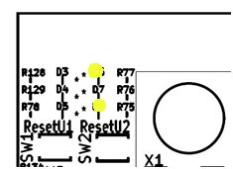Six yellow LEDs show the Rx and Tx digital signal status. See and Figure 9 for board position and Table 8 for the interpretation of the status LEDs. External frequency input (verified by LED D9 is discussed on page .

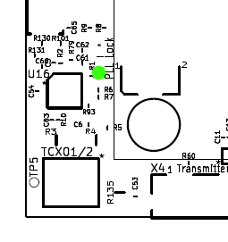

Figure 13 (L) shows Rx and Tx LED indicators and (R) shows location of LED D9.

|  |  |  |  |
| --- | --- | --- | --- |
| **LED**  **ID** | **LED**  **Color** | **Interpretation** | **Flash status** |
| D1 | Green | 3.3v regulator power status | On when powered |
| D2 | Green | 1.2v regulator power status | On when powered |
| Transmitter data status (from Chip U1B, CYUSB3011) | | | |
| D3 | Yellow/  orange | Not used in production RASDR |  |
| D4 | Yellow/  orange | Not Used in production RASDR |  |
| D5 | Yellow/  orange | Not Used in production RASDR |  |
| Receiver data status (from Chip U2B, CYUSB3011) | | | |
| D6 | Yellow/  orange | Rx command indicator | Flashes while DigiRED is receiving commands.  On in bootloader mode |
| D7 | Yellow/  orange | Tx command indicator | Flashes while DigiRED is sending data. On when data are streamed. |
| D8 | Yellow/  orange | Firmware indicator | Flashes when firmware is ok. On in bootloader mode |
| Frequency lock status | | | |
| D9 | Green | Frequency lock indicator | Green when frequency lock is achieved |

Table 8 DigiRED LED status indicators.

### Configuration

The DigiRED board is controlled by RASDRViewer application, see next chapter.

### Loading new firmware

From factory the RASDR receiver will be loaded with the latest firmware; however, updates will be available by email.

# RASDRViewer and RASDR Software Basics

## Introduction

For some, the ‘meat’[2] of the Software Defined Receiver is the software. This is the promise for developing algorithms that process the raw radio data to extract finer details physics and astronomoy. To others, the focus is on development of equipment that pushes the limits of exploration. There are various approaches to data processing. RASDRviewer is a ‘viewer’ and shows FFT output. The foci of RASDRviewer is to program MyriadRF, demonstrate via its GUI (Graphical User Interface) the existence and form of the data, and route the data to the background computer. RASDRviewer is in addition a data capture utility that selects and saves data for subsequent processing.

RASDRviewer[22] [23]is the primary software that controls RASDR2 and presents captured data to the user. It uses a Windows based GUI that is designed for portability to both the Linux and MAC platforms. This portability is mainly based on the use of the wxWidgets development tool that is available as open source freeware. wxWidgets abstracts most of the common graphical window objects to a common language that is applicable across all of the platforms. Thus the look and feel of the user experience is the same regardless of the platform being used. Loading and using RASDRviewer on a Windows operating system is straightforward. The Linux and MAC options have not been tested as compiled code on these machines. However, the use of RASDRviewer on a MAC bootcamp partition has been tested with Windows 8.1.

RASDRviewer is an extension of the Lime Microsystems FFTviewer to optimize radio astronomy functionality. The original FFTviewer presented three charts, I & Q samples vs time, I vs Q for system verification and an output display showing results of a large Fast Fourier Transform (FFT) that operates in near real time. The FFT is capable of delivering up to 16,384 frequency bins multiple times per second. The control of the system required knowledge of the Lime chip architecture and RF engineering theory.

For RASDRviewer, modifications have been made to customize the software for Radio Astronomy use. This includes optimization of control functions for radio astronomy use, addition of a Power vs Time plot, file outputs and inclusion of a simplified selection of the user options. Work is continuing to add additional features aimed at Radio Astronomy applications. This includes the Pulsar feature recently published in the SARA journal.

The system uses a combination of C, C++,wxWidgets, FFT-W and Open GL with the Code::Blocks Interactive Development Environment. The system uses a SARA driver that was based on a driver provided by Cypress, the maker of the USB3 chip on the RASDR2–Digi-Red board. These development tools have created a powerful GUI and data processing capability. The GUI provides the user interface in a format that is familiar to the user of the chosen platform. However, the complexity of the compilation chain can prove difficult to establish. This complexity has limited the porting of the system to platforms beyond Windows at this time (except for the MAC bootcamp platform mentioned above).

RASDRviewer currently operates on most Windows platforms that are in current use. This includes Windows 2000, Vista, XP, 7 and 8. It has been tested on Windows 7, XP and 8.1. Plans may include additional porting of the system to Linux and MAC platforms.

## Installing RASDRviewer

RASDRviewer runs under Windows XP, Win 7 or Win 8.1. It is available for download as described in one of the “new member” messages for the RASDR Users Group or in the README file following[24]. It should be noted that the readme text file will change with each subsequent version of RASDRviewer. New versions are released each couple of months.

## Architecture

The software is organized in classes, modules and files to allow maximum flexibility in the reuse of code. Threading, Call back and event timers are used to maximize the high speed processing of the data. High speed multiple core platforms will provide the maximum performance which includes data collection at 32 M Samples/Second and the full 28 MHz bandwidth of the RASDR2 board. Older computers will function at reduced speeds. Furthermore, older computers that don’t have graphics GL capability may need to be updated. Nvidia graphics cards made after 2009 are probably OK.

The system uses custom firmware that is loaded onto the FX3 chip in the Digi-Red board. This includes a unique SARA Vendor and Product ID (VID/PID) pair. This allows the user to connect to RASDR2 without concern of not finding the correct USB3 channel. The software uses this unique VID/PID together with a version register on the Lime Chip to verify that system connections are correct. These modifications to the firmware make the Cypress Driver unable to operate. Thus the user must use a SARA provided driver that matches the VID/DID.

The firmware provides not only the high speed data interface, but also a capability of establishing a Serial Peripheral Interface (SPI) bus to perform the control of the chips on RASDR2. In addition, the firmware provides the use of the General Purpose Input Output (GPIO) pins on RASDR2. Thus there is no need for a separate micro-controller or FPGA on RASDR2. This has significantly reduced the cost of RASDR2.

## Graphical User Interface

When the user executes RASDRviewer, they are presented with a screen that provides charts of the collected data, see the figure below:

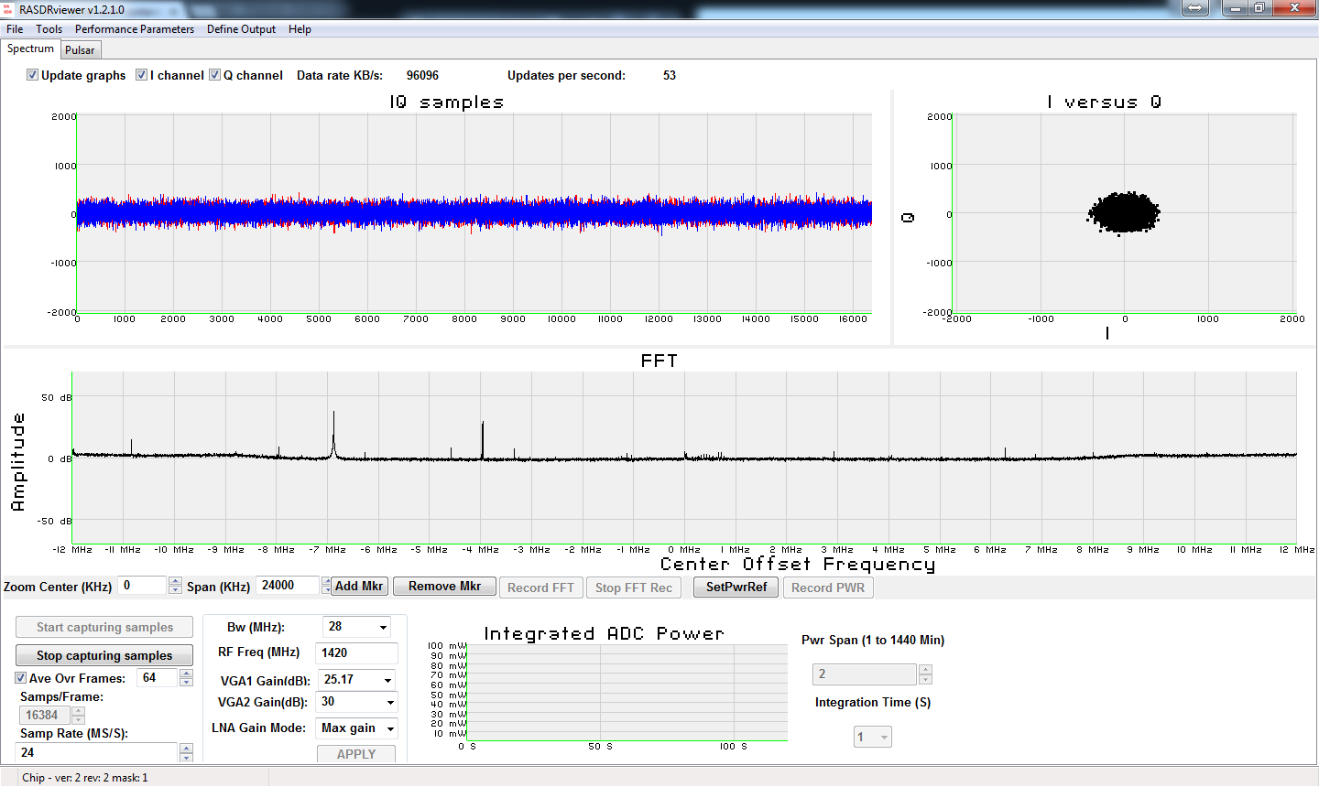

Figure GUI Start window of the RASDRViewer application

Needs to be updated for current format.

Starting in the upper left side, the In Phase (I) and Quadrature (Q) samples are displayed against time.

To the right, there is a chart that displays the phase relationship between the I and Q samples. Since a significant spectral line is present, the circle is present. The circle is created by the 90 degree relationship between the samples. This chart is used mainly to verify the system. However, it is a useful educational tool for students that are learning the phase relationship between I & Q signals and flags the existence of any possible imbalance between I and Q channels.

In the middle of the screen there is a display of the FFT output. The vertical axis is in dB. The horizontal axis is the frequency of the FFT bin at baseband. Zero frequency corresponds with the center RF frequency. The frequency bin bandwidth can be changed by using different sample rates and samples per frame that is set on the bottom left of the screen.

Figure below shows an enlarged portion of the screen where chip parameters can be set. The user can change the experiment parameters by using the controls in the bottom left section of the screen. See Figure 10 for enlargement. This is where one would set the frequency, bandwidth, sample rate, frame size and gain. The changes are not placed in effect until the user pushes the apply button. When the apply button is clicked, the system forwards the necessary commands via the SPI bus described above to the Lime chip on RASDR2.

The top left portion of the controls section on Figure 10 contains buttons which start and stop the capturing of the data. When the start button is clicked, the charts will show the results of the samples. The start button will also activate the “Apply” button which ensures that changes in parameters are included in the results. Just below the “Start” and “Stop” buttons is where the user can establish averaging of the FFT output. This is done by clicking the check box and setting the number of FFTs to average. Averaging is useful to enhance spectral lines by reducing the baseline noise. Since the baseline noise is random, its average value is reduced to the mean of the noise. Since the Spectral line is not (or partially) random, it is enhanced.

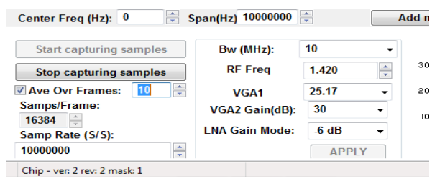

Figure Chip parameter settings

In the bottom right corner is a display of power at the ADC input. Figure below shows this portion enlarged. The power is calculated over a frame of complex samples creating a display of the RMS power in the frame. Although the values are in milliwatts, to obtain the corresponding total power at the antenna would require calibration. The main purpose of the power chart is for use during drift scan experiments. The power will peak when the desired object is centered in the antenna beam width.

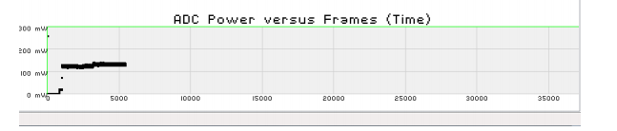

Figure ADC Power input

All of the charts have the feature where the user can change the range of the chart by dragging a box around the section of the chart to enlarge. Clicking on the left side of the chart restores the default ranges.

The FFT chart has the ability to set markers to help identify the specific frequency and peak value of a spectral line. The marker controls are below the FFT chart enlarged in Figure below. To add a marker, click the “Add Marker” button. Then move the cursor to the screen and click where the marker should be placed. The marker can be moved left or right by dragging it with the mouse. With a little bit of practice, the user can find the peak value. The user can also set the span and center frequency of the display.

The charts are updated multiple times per second. The time between updates varies with different setup parameters. The frequency (updates / Second) is shown on the top of the screen.

## FFT Output to Disk

Recording data to a disk file or files can be accomplished by using the Define Output menu item on the second line of the screen. Clicking the button will bring up a sub-menu of the types of outputs available (only FFT output at present). Clicking the FFT output menu item will bring up an overlaid screen for the setup of the parameters of the recording. Figure 10 is a screen shot of this window. On the left of the top line the user can select the File type. Two options are available. The first is for use in MS-Excel where the number of frequency bins is reduced to a maximum of 128 to allow Excel to be able to process a 3D chart in a reasonable period of time. The user can select the General Purpose output for use in other post processing programs. The output in this case uses whatever sample rate, samples per FFT and bandwidth is present in the controls on the bottom left of the main screen. The general purpose output produces a comma delimited data file with a .csv file extension.

The top center of the setup window is used to determine the behavior in the event multiple record sessions are desired. There are two options one to append the data to the previous file and one to create a new file with a suffix number in the file name.

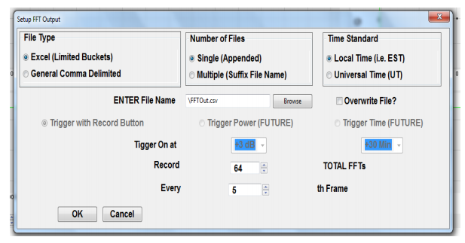

Figure 17 FFT Recording configuration

The top right section of the setup screen is used to define the type of time stamp to be used. There are two options Universal Time and Local Time. The second section of the Setup Window is used to define the file name. A browse button is included to allow the user to find the directory and file name for the data. If the file already exists, it is necessary to either select a different file name, or check the “Overwrite” box. On the next line, in the future, the user will be able to define the condition which will trigger the recording to the disk. At present, only the manual trigger is operational. Near the bottom of the screen is where the user can establish how many FFTs to record and how frequently.

The bottom section contains the “OK” and “Cancel” buttons. To abandon the setup, click the cancel button. To establish the selected parameters, click ok.

Finally the user clicks the “Record FFT” button which is located on the line below the FFT chart. See Figure 10. This button is only active when data is being captured by use of the “Start Capturing Samples” button on the left of the screen and an output is defined. The defined number of FFTs will be recorded on the disk. The “Stop FFT Rec” button can be used to stop recording data before the defined number of FFTs is recorded. Once the recording is stopped, the “Record FFT” button can be clicked for additional data as defined (either appended or new file suffix).

# Basic Radio Astronomy with RASDR (discussion and examples)

RASDR has been applied in several modes[25] to solve some common experimental challenges encountered by members of the community of amateur radio astronomers.

A few examples will be presented in Chapters 7) and 8) but RASDR is a new tool and 2015 will be the first year of availability for purchase. Results of operation in several RF spectral bands will be shown and discussed. These results include monitoring HI emissions from distant clouds, interfacing to the NRAO 40’ radio telescope to record spectral data; interfacing to the NRAO 20m radio telescope[26] to record and extract information from data taken at different observing sessions; monitoring a 10MHz section of the commercial FM band with a wire antenna; and monitoring a section of the crowded HF short wave band with a wire antenna.

## Hydrogen HI Spectroscopy. L-band (1420 MHz)

Using RASDR2 for observing an HI hydrogen cloud signal requires a suitable antenna, a high-gain preamp (LNA) and perhaps a supplementary amplifier and signal averaging to extract the HI signal from the RF noise

One may ask how much sensitivity is needed.  A popular special-purpose spectrometer that works well for observing HI emissions from distant hydrogen clouds is SpectraCyber II[27], which was invented and constructed by RASDR team member Carl Lyster.

As a point of reference, the SpectraCyber bin width is about 5 KHz. If we desire to cover 10MHz of HI spectrum then we probably require about 2000 frequency bins or about 2048 samples/FFT. One may choose the a higher number of samples/FFT observe more detail, although more averaging would be required.. One of the significant advantages of RASDR2 is that it has a high bandwidth.

RASDR2 control data consist of only a few values and they are discussed in Chapter 6). Based on the preceding discussion, an initial data screen for HI spectroscopy is shown in Figure 14 Initial choices of RASDR2 control parameters for comparison with typical SpectraCyber results, were not the final selection.. , with non-default values shown in red.



Figure Initial choices of RASDR2 control parameters for comparison with typical SpectraCyber results, were not the final selection.. Better results were obtained by choosing minimum BW for this narrow spectral region. See text for choice of values shown in red.

The first tests with these settings provided a noisy graphical output. The LNA gain used in this series of measurements was only 15dB and skies were cloudy. In general, one expects to average over many samples. Initial runs with 99 and 998 samples (each sample consisting of an average over 64 frames) produced the output shown in Figure 15. It is clear that more samples must be included in the averaging process, which will require a small software change from the current program. Typically, more gain should be used (see discussion of . Note that the noise spurs (that appeared only after averaging) are about 9 dB above the floor and they are present in both tests.



Figure The importance of spectral averaging is shown with processing of 99 frames (left) and 998 frames (right). Control settings were as shown in Figure 14. USB2 connectivity was used to an IBM laptop running WinXP, and using a USB2 interface.

A second necessity is to remove the background noise and normalize for system response. Figure 16 shows the result of subtracting the two files shown in Figure 15 to remove the common baseline variation and the 9 dB spurs. This component is not present in the 998 FFT average.

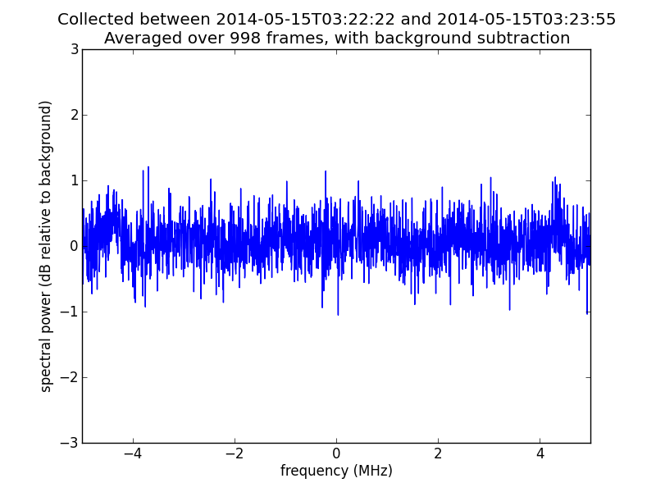

Figure This figure is the difference file using the 99 file average and the 998 file average shown in Figure 15The 2dB noise component from Figure 15 (left) is all that remains. The common feature is removed, and the same method can be used to remove system noise or select for ‘genuine’ signals.

## System Gain Considerations

The question arises as to how much amplifier gain and how much post-processing is necessary to detect H1 signals. A user’s system might be configured as shown in Figure 17.

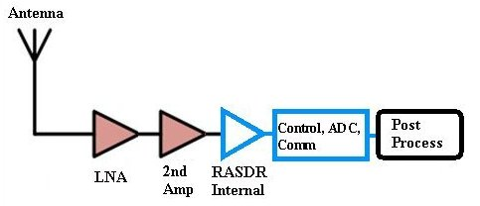

Figure Example system configuration for H1 detection. RASDR hardware is outlined in blue.

Table 9 presents examples of rough calculation of system gain for possible monitoring of H1 signals:

|  |  |  |  |
| --- | --- | --- | --- |
| **Component** | **Low (dB)** | **Nominal gain (dB)** | **High (dB)** |
| Antenna | 20 | 30 | 40 |
| LNA | 18 | 25 | 30 |
| Buffer Amp | 20 | 30 | 40 |
| RASDR (internal gain) | 61 | 61 | 61 |
| **Total System Gain** | **109** | **136** | **171** |

Table 9. Examples of system gain from components for monitoring H1 signals.

The nominal gain for this example is 136dB. RASDR gain is adjustable so for this example, the internal amplifiers have been set to a maximum internal gain of 61dB. To bring a modest H1 signal to a detectable level, the desired System Gain might be, depending on what is in the antenna beam, from 125-140dB. Some systems will not require a buffer amplifier or post-processing for weak signals while others may require this. The user may boost the amplifier gain or rely on numerical averaging, either in RASDRwindows or in post-processing with Excel or Python, to observe the signal.

For post-processing to be useful, the input signal to RASDR must have remained above the internal noise floor during the measurement. Depending on the noise statistics, a rule of thumb is that the power level of the signal+noise from the external amplifier chain is above the RASDR noise floor by greater than 5%. This will ensure that the signal is being digitized and that subsequent processing can improve the weak signal.

# Postprocessing

RASDRviewer can output CSV (comma-separated-value) files in long-duration format (large files permitted), or in a shortened format that complies with Excel limitations. These data files are useful for analysis via Excel or other programs such as Python routines. Sample Python code examples may be shared via the User’s Group [28]:

<https://groups.yahoo.com/neo/groups/RASDR/files/PostprocessingSoftware/>

# Basic Radio Astronomy below RASDR design frequency

This chapter describes the application of upconverters to extend RASDR to frequencies from 20400MHz,l below the nominal limits of the bare RASDR unit. Software control was via RASDRwindows.

## Radio Astronomy in the VHF band (80-190 MHz)

It is highly desirable to extend RASDR2 coverage to lower-frequency RF bands. Such an extension makes it far more useful to SARA members.

This section describes extension of operation to the VHF band, specifically 80-190 MHz. This band is useful for solar monitoring and for meteor detection and it also contains an AM aircraft band, amateur radio activity, commercial FM band that are interesting for performance verification, and the output Intermediate Frequency (IF) band for the 40’ Green Bank Radio Telescope[29]. To add functionality below the intrinsic RASDR2 band, an upconverter was designed and constructed.

The basic LM6002d covers a wide frequency range from 300-3800 MHz. An amateur-built VHF upconverter extends reception to an input frequency band between 80-190 MHz. Filters were included to reject incoming signals that upon mixing would have been upconverted to below 300MHz, to avoid the third harmonic of the local oscillator (LO) that was used for mixing, and to remove the LO fundamental frequency component.

Our VHF upconverter uses the third harmonic of a 100MHz oscillator [30][31].  The 3rd harmonic (300MHz) is mixed with the input signal.  The following basic components are also required, plus about 25 additional inexpensive components:

Crystal oscillator Raltron CO19025-100.000MHz [31]  
 Low Pass Filter                     LFCN-225 [32]              
 Mixer,               IAM81000 [33]

Output Bandpass filter combination PHP-400[34]

LFCN-225 [32]                          
   
Figure 18 shows the functional diagram of the VHF upconverter constructed for RASDR2 tests.

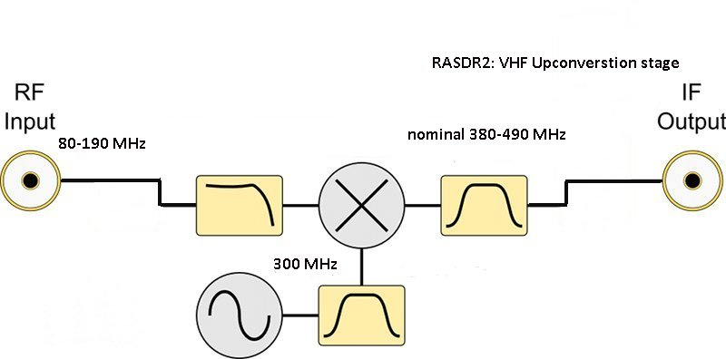

Figure 22. Block functions of the VHF converter show conversion of 80-190MHz VHF signals into the RASDR2 input band acceptance range.

Several filters are shown, the input low pass filter to avoid VHF components in the input from reaching the mixer; the 300 MHz bandpass filter to clean up the third harmonic of the oscillator, and the output bandpass filter (two filters are used in our unit) to select just the frequency components desired from the mixer stage.

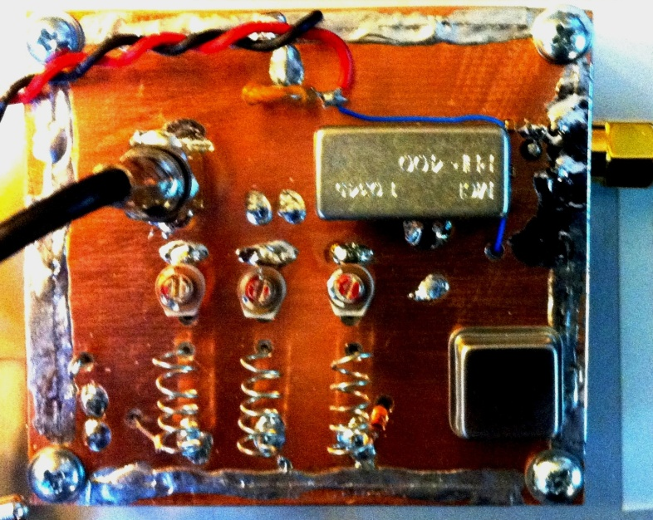

Figure Completed VHF converter used with RASDR2. Input is via the coax cable while the output is via the SMA connector shown on the upper right.

The circuit shown has a mixer with about 10dB gain resulting in no overall signal loss for the unit. The noise floor is about -120 dBm.

The unit is intended for several applications, including meteor detection, spectroscopy with the NRAO 40’ antenna, and solar monitoring. A convenient test signal is the commercial FM band, using a random wire antenna about one wavelength long. A random length of hooki[ wire was connected to the input of the upconverter

Figure 20 shows a 10 MHz section of the commercial FM band taken directly from the RASDR2 GUI video output, using a 2m piece of hookup wire for an antenna, and the upconverter of Figure 19.



Figure Commercial FM band. The antenna was a random wire about 2m long, connected to theVHF upconverter, then to RASDR2. The red marker was added on the RASDR2 display to denote a local FM station broadcasting at 102.113 MHz.

Selecting RASDR2 internal filters to narrow the band to 2.5 MHz width, demonstrates a practice that is useful to reject interfering signals outside the region of interest and avoiding any intermodulation. The result of setting the bandwidth to 2.5 MHz is shown in Figure 21.



Figure RASDR2 internal narrow-banding was chosen to select a region of interest. In practice, narrow banding is useful to reject unwanted outlying signals (noise).

RASDR2 output is more information-rich than suggested here. Figure 22 shows the complete primary-window display of a 10MHz-wide band centered at 90 MHz, with the RASDR2 marker function used to denote a couple of interesting local FM stations. Additional windows provide “Tools” and “Define Output”. As data were taken, the writer was listening to 91.9 MHz (red triangle marker) on the stereo.

## Band-Extension Spectroscopy Testing and application to wide-band VHF monitoring



Figure The complete RASDR2 video output with VHF input shows the input signal stream as digitized (I and Q values); the I vsQ plot (a circle if there is a single coherent source, the FFT spectral display with markers if selected, digitization and internal gain settings, and a power vs. time plot. The ratty power vs. time plot on the lower right shows the result of moving the antenna.

## Using the VHF converter to access the NRAO 40’ dish

Radio access to signals collected by the NRAO 40’ telescope are restricted to using the local IF feed. This VHF upconverter was designed with this challenge in mind. Study of HI using RASDR2 at NRAO, have been done by dialing in the 40' telescope local oscillator to 1315 MHz and measuring the signal at the output IF feed (1420 -1315 MHz), which would be at 105 MHz.  This was upconverted to 405MHz and examined with RASDR2.

## RASDR Spectroscopy in HF band (2-80 MHz)

RASDR2 operation has been described as applied from 400MHz to 4GHz, and with the VHF upconverter, to the input range from 80-190 MHz. To demonstrate functionality in the HF band from about 2-66 MHz, we used an upconverter obtained from Nooelec [35] that upconverts this HF input band to a 102-166 MHz output band. Thus the output is compatible with input of the VHF converter described earlier.

The Nooelec upconverter functionality is shown in Figure 23. The device shown has a measured internal loss of about -10 dB of signal. The noise floor is about -80 dBm. This device was used with a 100 MHz crystal oscillator, but one can also obtain it with a 125 MHz oscillator. If this component selection is made, then the output will be shifted by 125 MHz, and avoid the commercial and aircraft bands.



Figure Functionality of the Nooelec upconverter is as shown. The RF input is nominally specified 0-65 MHz and the measured performance covers in the range 2-66 MHz. Filter functions are as described with reference to Figure 4.

For testing purposes, the HF upconverter was mounted as shown in Figure 24, where it is the PC board on the lower left. The VHF converter discussed earlier is shown on the upper right.

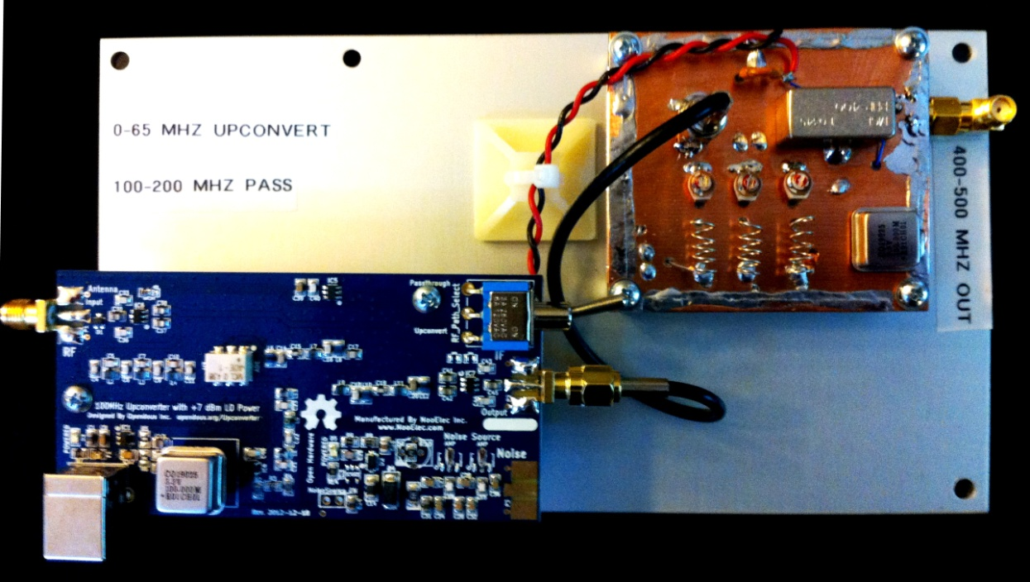

Figure Two upconversion stages are shown here, which provide for conversion of the 2-66MHz portion of the HF band to the 402-466 MHz band prior to processing with RASDR2. The Nooelec converter is on the lower left while the VHF converter described earlier appears at the upper right.

Results were as might be expected using an antenna very short (2m) compared to the frequency. Figure 25 shows a 5.5 MHz section of the HF band centered on 15 MHz. The plot contains signals, spurs, and noise The lesson from this figure is that one must use a respectable antenna and preamplifier, possibly a preselection filter, and background subtraction for a noisy band.



Figure Noisy 5.5 MHz section of the HF band centered on 15 MHz. This measurement was made with an electrically short antenna and no preamplifier. It shows various sources of noise including some from the Nooelec upconverter. This experiment suggest the importance of a decent antenna, more preamplification and background subtraction.

# Operating RASDR beyond the limits: SETI and weak signals

Extraterrestrial civilizations[3] may use unknown transmission modes for transmission of information. Nevertheless they are probably constrained by physics (of which we know a part) to the electromagnetic spectrum for long-range transmissions. RASDR covers a useful section of this spectrum for communication with civilizations of the same level of technological development as our own.

Various techniques exist for pulling weak signals out of the noise. They include using larger antennas, employing lower-noise preamplifiers, signal averaging, and correlating received signals (mostly noise) with known reference values. This is a useful technique for pulsar discovery and investigation, and might also be useful for SETI (Search for Extraterrestrial Intelligence).

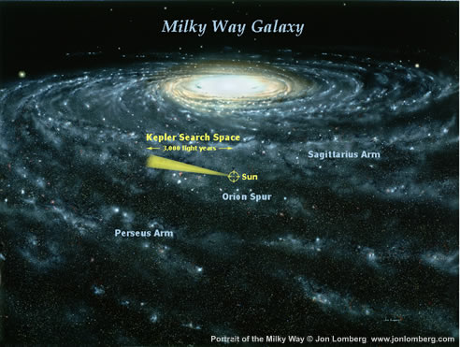The physics of natural (non life-based) systems can generate periodic and structured signals. Examples include periodic solar emissions, Jovian Io-related radio emission ‘storms’, pulsar signals, structured signals (Faraday bands) arising from ionospheric effects – and SETI. The Kepler mission searches a very tiny section of the sky, and thus a tiny nearby section of the Milky Way [36]**Error! Reference source not found.** The number of probable extra-solar planets discovered by the Kepler mission alone exceeds 4500 in number and a significant fraction of these lie in the ‘Goldilocks zone’ where life as we know it might prosper.

Figure The Kepler mission search zone considers a tiny fraction of our galaxy.

Furthermore, life may indeed inhabit artificial worlds[37][38]. Thus as Seth Shostak said, “…the broader point is that we now know two things that we didn’t know 20 years ago. First that planets, including ones that might be like Earth, are incredibly plentiful in the visible universe. There could be a billion trillion cousins of our world. Second, life got started on Earth very early.” Of course, coincident transmission and reception of radio signals from different solar systems requires degrees of proximity in both space and cultural level.[4] Meanwhile, the rich physics of the universe provides many opportunities to detect and study weak signals.

The applicability of RASDR to SETI activities has been noted[39], and successful detection of signals from intelligent non-human life will probably one day be accomplished.

# Appendices

## RASDR Drivers

Microsoft Certified drivers are available for the RASDR device at [rasdr.org](http://rasdr.org/).

|  |  |
| --- | --- |
| Vendor ID[5] | 0x1D50 |
| Product ID - RX | 0x6099 |
| Product ID - TX | 0x609a |
| Product ID - Bootloader | 0x609b |

Table 10 - RASDR receiver USB IDs

Table 10 above details the USB IDs that are used by the RASDR receiver. There are some cases when an unprogrammed board will identify itself as ‘Westbridge’ or ‘Cypress USB Bootloader’. If this is the case, please refer to section b) below on updating the firmware.

## RASDR Firmware

To operate properly, the RASDR receiver must contain the VID/PID described in the above table. To support firmware updates, the receiver can be put into bootloader mode so that the firmware update can take place. This is done by disconnecting the RASDR receiver from the USB port on the computer and setting the switch to ‘PROG’ or removing the jumper on the J2 connector of the DigiRED board.

When the RASDR receiver is plugged into the USB again, it will identify itself as the bootloader above, or ‘Westbridge’[6]. Either way, the procedure for firmware update is the same:

Open the CyControl.exe program that is provided in the software distribution folder or ‘CyControl.zip’ from the rasdr.org site.

Select the ‘Cypress USB Bootloader’ in the window

Select Program->FX3->SPI FLASH

You may see a 2nd device driver association. If that occurs, simply wait until it is finished and then select the ‘Cypress USB Bootloader’

IMPORTANT: change the switch from ‘PROG’ to ‘RUN’ or fit the jumper on J2 connector of the DigiRED board. If you do not do this before the next step, the firmware will fail to upload.

Choose ‘usb_rx.img’ from the software distribution folder ‘firmware/’

Observe that the ‘RASDR Radio Astronomy RX Interface’ is loaded.

You may need to re-associate the device driver, see section a) above.

Figure 28 thru Figure 32 detail the steps you are likely to encounter using the CyControl program.

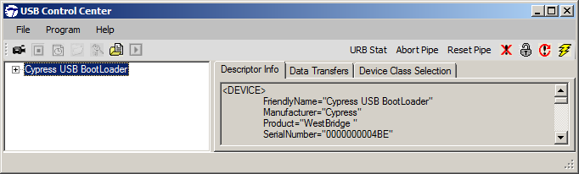

Figure 31 - CyControl program (Firmware update step 1)

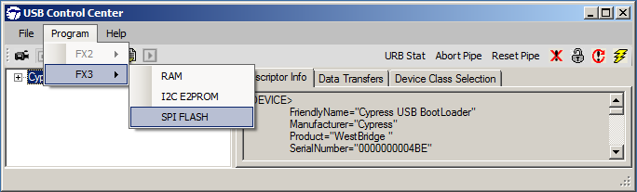

Figure 32 - CyControl program (Firmware update step 2)

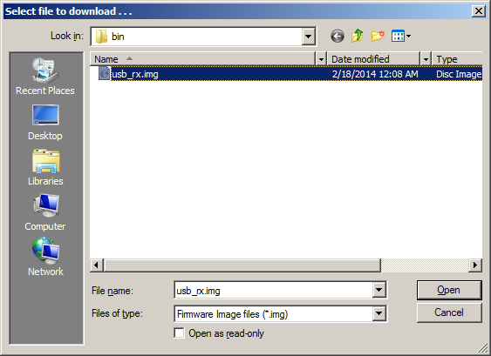

Figure 33 - Select programming file (Firmware update step 5)

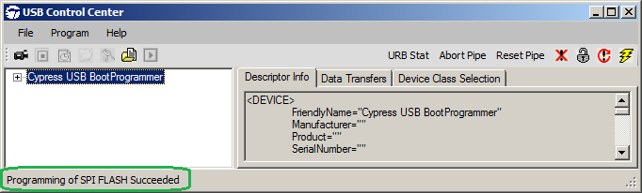

Figure 34 - Firmware Update Success

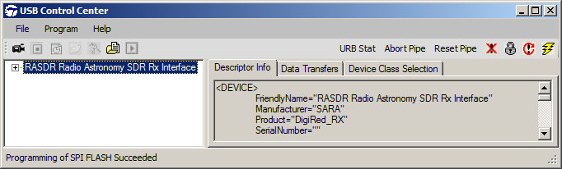

Figure 35 - Reinsert USB after Firmware update

## Troubleshooting

It is recommended that the new user read (at least) the contents and Chapter 1 of this Guide. The FAQs may prove helpful.

A very few users may skip the README First (Chapter 1). This contains useful sources of information and specific links to the RASDR Users Group and other RASDR support groups, as well as email addresses for users with specific questions.

## General and Frequently-Asked Questions (FAQs)

Q: Will RASDR work using USB2 cables/connectivity?

A: Yes, but with reduced bandwidth. An adaptor can be added to permit USB3 input, but not all such USB2/USB3 adaptors are equivalent, since different chipsets are used by different vendors. For desktop PCs, good results have been obtained with the Konig Electronic CMP-PCIE2USB3 pci express card with the the NEC/Renesas UPD720202 chipset, available from Amazon for about $36. An ASUS u3s6 PCIE didn’t work well. An Inateck KT4007 board functioned well in tests.

Q: May I use an old computer?

A: Older computers that don’t have graphics GL capability may need to be updated. Nvidia graphics cards made after 2009 are probably OK.

Q: How do I avoid Excel files becoming large and unmanageable?

A: Set the file “save spectral span” to a subset of the displayed BW. The display FFT span is intended to be a way to zero in on a narrow portion of the bandwidth. It is used to obtain a smaller number of columns on the output FFT file. This is done by selecting the option on the file setup screen. The setting of the span to match the sample rate is intended to prevent displaying meaningless data.

Q: How significant is the Doppler shift for H1 measurements?

A: We see signals from neutral hydrogen atoms (H1 emission) at different frequencies. All those H1 sources are in motion, and a good rule of thumb is to examine the velocity Doppler shift over a 1.5MHz section of spectrum. One can compute the velocity v for a given frequency from the Doppler shift:

$$\frac{v}{c}= ∆f/f$$

where $v$ is the velocity in question, $c$ is light speed (3e8)m/s, $∆f$ is the frequency range (1.5e6)Hz, and $f$ is 1.42e9 Hz.

This gives $v$ = 316km/s, so the conversion factor is 3.16km/s per 1.5MHz.

Q: I am thinking about adding an RASDR2 that you describe and another antenna, probably a dish with much larger aperture. Other than the limitation you mention about SPCY (5kHz spectra mode bandwidth) How do you think it will compare with the RASDR2 ?

A: I like both instruments. SPCY is a great special-purpose instrument and if you want to take H1 spectra, then it's the way to go. But RASDR2 can be reconfigured by software to do a variety of things. I hope that you will work with us on some creative projects. I've an interest in SETI and have stressed its importance to TVIW. Paul Shuck and I worked together on one of these talks -- <https://www.youtube.com/watch?v=Ci4cwZtub5U>.

Q: I realize that is a very open ended question but I am thinking about stability of the oscillators to do RA as well as ability to do good radio astronomy and overall ease of use for someone who is not good with software and no programming ability ?

A: RASDR2 has a very stable TCXO. In addition, it has an SMA connector to connect to an external GPS-stabilized frequency reference. These GPS-stabilized sources are available from ebay. The old ones used Trimble GPS and were about $300 but the new ones (TCXO or Rb clock versions) appear to be about $140. I haven't used them, but we stabilized to the NRAO facility clock last year for measurements at the SARA meeting.

Q: Does the RASDRviewer have the math programs to do FFT analysis in it or does it access the math software come from some other site ?

A: It contains the math programs. The FFT analysis in RASDRviewer is done by FFTW, developed at MIT.

## RASDR & Myriad RF connectors details

### X1 Connector - DigiRed to Myriad

The Myriad-RF board X3 connector (type FX10A-80P0) is pin compatible with J1 connector on interface board. It provides the digital and SPI interface for LMS6002DFN together with the supply voltage and GPIO control for RF switches for Myriad-RF board. The pin descriptions on this connector are given in the table below:

|  |  |  |  |
| --- | --- | --- | --- |
| **Pin No** | **Pin Name** | **Type** | **Description** |
| 1 | +5 V | in DC | +5 V power supply |
| 2 | +5 V | in DC | +5 V power supply |
| 3 | +5 V | in DC | +5 V power supply |
| 4 | +5 V | in DC | +5 V power supply |
| 5 | GND |  | Ground pin |
| 6 | GND |  | Ground pin |
| 7 | +3.3V | in DC | +3.3 V power supply optional |
| 8 | +3.3 V | in DC | +3.3 V power supply optional |
| 9 | +3.3V | in DC | +3.3 V power supply optional |
| 10 | +3.3V | in DC | +3.3 V power supply optional |
| 11 | GND |  | Ground pin |
| 12 | GND |  | Ground pin |
| 13 | - |  | Not used |
| 14 | - |  | Not used |
| 15 | - |  | Not used |
| 16 | - |  | Not used |
| 17 | GND |  | Ground pin |
| 18 | GND |  | Ground pin |
| 19 | TXIQSEL | in cmos | TX digital interface IQ flag |
| 20 | - |  | Not used |
| 21 | - |  | Not used |
| 22 | - |  | Not used |
| 23 | TXD0 | in cmos | DACs digital input, bit 0 (LSB) |
| 24 | TXD1 | in cmos | DACs digital input, bit 1 |
| 25 | TXD2 | in cmos | DACs digital input, bit 2 |
| 26 | TXD3 | in cmos | DACs digital input, bit 3 |
| 27 | GND |  | Ground pin |
| 28 | GND |  | Ground pin |
| 29 | TXD4 | in cmos | DACs digital input, bit 4 |
| 30 | TXD5 | in cmos | DACs digital input, bit 5 |
| 31 | TXD6 | in cmos | DACs digital input, bit 6 |
| 32 | TXD7 | in cmos | DACs digital input, bit 7 |
| 33 | TXD8 | in cmos | DACs digital input, bit 8 |
| 34 | TXD9 | in cmos | DACs digital input, bit 9 |
| 35 | TXD10 | in cmos | DACs digital input, bit 10 |
| 36 | TXD11 | in cmos | DACs digital input, bit 11 (MSB) |
| 37 | GND |  | Ground pin |
| 38 | GND |  | Ground pin |
| 39 | RXIQSEL | out cmos | RX digital interface IQ flag |
| 40 | - |  | Not used |
| 41 | - |  | Not used |
| 42 | - |  | Not used |
| 43 | RXD0 | out cmos | ADCs digital output, bit 0 (LSB) |
| 44 | RXD1 | out cmos | ADCs digital output, bit 1 |
| 45 | RXD2 | out cmos | ADCs digital output, bit 2 |
| 46 | RXD3 | out cmos | ADCs digital output, bit 3 |
| 47 | GND |  | Ground pin |
| 48 | GND |  | Ground pin |
| 49 | RXD4 | out cmos | ADCs digital output, bit 4 |
| 50 | RXD5 | out cmos | ADCs digital output, bit 5 |
| 51 | RXD6 | out cmos | ADCs digital output, bit 6 |
| 52 | RXD7 | out cmos | ADCs digital output, bit 7 |
| 53 | RXD8 | out cmos | ADCs digital output, bit 8 |
| 54 | RXD9 | out cmos | ADCs digital output, bit 9 |
| 55 | RXD10 | out cmos | ADCs digital output, bit 10 |
| 56 | RXD11 | out cmos | ADCs digital output, bit 11 (MSB) |
| 57 | GND |  | Ground pin |
| 58 | GND |  | Ground pin |
| 59 | RXCLK | in cmos | RX digital interface clock |
| 60 | TXCLK | in cmos | TX digital interface clock |
| 61 | - |  | Not used |
| 62 | - |  | Not used |
| 63 | GND |  | Ground pin |
| 64 | GND |  | Ground pin |
| 65 | GPIO0 |  |  |
| 66 | RESET | in cmos | Hardware reset, active low |
| 67 | GPIO1 |  |  |
| 68 | SPI_MOSI | out cmos | Serial port data out |
| 69 | GPIO2 |  |  |
| 70 | SPI_MISO | in/out cmos | Serial port data in/out |
| 71 | - |  | Not used |
| 72 | SPI_CLK | in cmos | Serial port clock, positive edge sensitive |
| 73 | GND |  | Ground pin |
| 74 | SPI_NCSO | in cmos | Serial port enable, active low |
| 75 | CLK_IN | in cmos | PLL reference clock input |
| 76 | - |  | Not used |
| 77 | GND |  | Ground pin |
| 78 | - |  | Not used |
| 79 | TXEN | in cmos | Transmitter enable, active high |
| 80 | RXEN | in cmos | Receiver enable, active high |
| 81 | GND |  | Ground pin |
| 82 | GND |  | Ground pin |
| 83 | GND |  | Ground pin |
| 84 | GND |  | Ground pin |
| 85 | GND |  | Ground pin |
| 86 | GND |  | Ground pin |
| 87 | GND |  | Ground pin |
| 88 | GND |  | Ground pin |

Table 11 X3 connector pin description

A figure of the connector is provided below:

The Myriad-RF board is directly plugged into the X1 connector. The digital I/Q connector is a digital transmit (TX) and receive (RX) interface to the ADC/DAC of the LMS6002D.

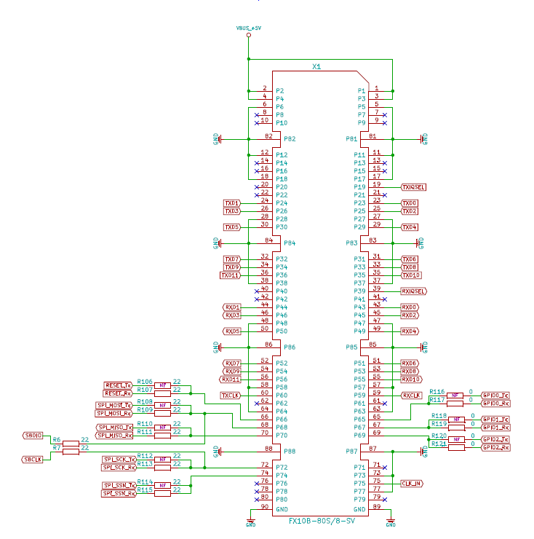

### X2 Connector - FX3 JTAG interface

FX3’s JTAG interface has a standard five-pin interface to connect to a JTAG debugger in order to debug firmware through the CPU-core's on-chip-debug circuitry. The FX3’s is selected via the JTAG switch.



Figure 36 JTAG conector.

### X3 Connector - PPS / Clck-ext and GPIO Connector

A GPIO connector is available on the DigiRED board for expansion.

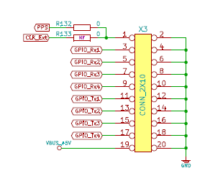

## X7 Connector - Input Reference Frequency Provision

The Input Reference Frequency has performed well in tests at NRAO, where a 10MHz facility reference signal was used.. As indicated above, the PPS feature is currently not supported, but is expected to be activated in future firmware, by providing 1Hz 3.3V pulse with 10% duty cycle on the port.

CLK_Ext will provide the clock from the Si5356 to the user if required.

The 10 MHz reference input drives an Analog Devices ADF4002 PLL chip on the DigiRED board. When the reference frequency is present and the PLL is locked to it, the green LED D9 (see Figure 28) will be illuminated.



Figure LED D9 is illuminated green to denote frequency lock.

The input signal should be a square wave or clipped sine wave with LOW/HIGH voltage of 0 and 3V (2.7 - 3.3V max value range). The ADF4002 reference input is a CMOS type with a nominal threshold of 1.5V and a dc equivalent input resistance of 100 kΩ. Thus expected current draw from the reference is in the order of 100µA.

The RASDR firmware is hard coded to use 10 MHz as an input, but there could be an option for setting the input reference frequency variable in the future if needed. The ADF4002 feeds the clock distribution chip si5356. The clock distribution chip feeds the down conversion Rx PLL as well as the ADC sample clock. The software sets the values of these devices in a transparent manner to the user. For example when the user changes the RF center frequency on the screen appropriate registers are set via the SPI bus to change the frequency. Likewise, registers are set when the user changes the sampling rate.

An example reference clock could be based upon either an OCXO or Atomic clock, possibly locked to GPS time for precise PPS signalling.

# References

|  |  |
| --- | --- |
| [1] | SARA, "RASDR – Radio Astronomy Software Defined Radio," 2015. [Online]. Available: http://www.radio-astronomy.org/rasdr. [Accessed 2015]. |
| [2] | Lime, "Lime Microsystems Field Programmable RF (FPRF) Transceiver IC," Lime Microsystems, 2015. [Online]. Available: https://github.com/myriadrf/LMS6002D-docs. |
| [3] | Digikey, "Digi-Key Catalog," Digikey, 2014. [Online]. Available: http://www.digikey.com/product-search/en?x=0&y=0&lang=en&site=us&keywords=myriadRF. |
| [4] | RASDRgroup, "RASDR – Radio Astronomy Software Defined Radio," 2014. [Online]. Available: http://rasdr.org. |
| [5] | Users, ""RASDR User's Group"," 2015. [Online]. Available: https://groups.yahoo.com/neo/groups/RASDR/info. |
| [6] | Github, 2015. [Online]. Available: https://github.com/myriadrf/RASDR. |
| [7] | P. Oxley, B. Vacaliuc, D. Fields, C. Lyster, S. Kurtz and Z. Tamosevicius, "RASDR update," *Radio Astronomy -- Journal of the Society of Amateur Radio Astronomers,* no. January-February, p. 72ff, 2014. |
| [8] | LimeMicrosystems, "Field Programmable RF (FPRF) Tranceiver IC," Lime Microsystems, 2014. [Online]. Available: https://github.com/myriadrf/LMS6002D-docs. |
| [9] | Myriadrf, "Home page of Myriadrf," [Online]. Available: http://myriadrf.org/. [Accessed 20 May 2013]. |
| [10] | Myriad, *Personal Communications to RASDR team,* 2013. |
| [11] | B. Vacaliuc, D. Fields, P. Oxley, S. Kurtz, C. Lyster, R. Vadoklis and Z. Tamosevicius, "Production Manufacturing Plan for RASDR2 Appliance," *Proceedings of the Annual Meeting of the Society of Amateur Radio Astronomers. NRAO, Green Bank WV,* 2014. |
| [12] | P. Oxley, D. Fields and S. Kurtz, "RASDR2 Control and Analysis Software," *Proceedings of the Annual Meeting of the Society of Amateur Radio Astronomers. NRAO, Green Bank WV,* 2014. |
| [13] | S. o. A. R. A. SARA, "Society of Amateur Radio Astronomers Home Page," 2015. [Online]. Available: www.radio-astronomy.org. |
| [14] | Wikipedia, "Radio_spectrum," 2014. [Online]. Available: http://en.wikipedia.org/wiki/Radio_spectrum. [Accessed 11 May 2014]. |
| [15] | D. Fields and N. Tesla, "Detection of Jupiter Radio Emissions below the Plasma Cutoff Frequency: Implications for SID Monitoring," *Annual Meeting of SARA at NRAO, Green Bank, WV,* 2011. |
| [16] | J. Avellone, "Detection of Jovian VLF Noise," *Radio-Astronomy Journal,* no. March - April, p. 48ff, 2014. |
| [17] | D. Fields, R. Kennedy and K. Roy, "Interplanetary Radio Transmission through Serial Ionospheric and Material Barriers," *Genta, Giancarlo, Ed; Proceedings of the Severnth IAA Symposium on Relalistic Near-Term Advanced Scientific Space Missions: Missions to the outer solar system and beyond.,* 2011. |
| [18] | A. R. R. L. ARRL, "Radio Amateur's Handbook (purchase)," ARRL, 2015. [Online]. Available: http://www.arrl.org/shop/ARRL-Handbook-2013-Softcover-Edition. |
| [19] | S. o. A. R. A. SARA, "Radio Jove Project," 2015. [Online]. Available: http://radio-astronomy.org/node/211. |
| [20] | L. M. S. LMS RDK, "myriad-RF reference development kit," 2015. [Online]. Available: https://myriadrf.org/projects/rdk/. |
| [21] | L. M. S. LMS, "myriadRF projects," 2015. [Online]. Available: https://myriadrf.org/projects/lms-suite/. |
| [22] | P. Oxley, D. Fields and S. Kurtz, "RASDRWin: Companion Software for RASDR," *Proceedings of the Annual Meeting of the Society of Amateur Radio Astronomers,* no. July 14-17, 2013. |
| [23] | P. Oxley and D. K. S. Fields, "RASDRviewer: RASDR2 Control and Analysis Software," *Proceedings of the Annual Meeting of the Society of Amateur Radio Astronomers,* no. June 29-July 2, 2014. |
| [24] | RASDRviewer, "RASDRviewer downloads," 2015. [Online]. Available: https://groups.yahoo.com/neo/groups/RASDR/files/RASDRviewerSoftware/. |
| [25] | D. Fields, P. Oxley, B. Vacaliuc, S. Kurtz, C. Lyster, C. S. Z. Tamosevicius and S. Berl, "Radio Astronomy with RASDR2," *Proceedings of the Annual Meeting of the Society of Amateur Radio Astronomers. June 29-July 2, 2014, at NRAO, Green Bank WV,* 2014. |
| [26] | P. Oxley, D. Fields, B. Vacaliuc and C. L. a. F. Ghigo., "Detection of Narrow Spectral Features using RASDR2 and the NRAO 20m Telescope," vol. p.90, no. July-Aug, 2014. |
| [27] | J. Bernard, "SpectraCyber I/II™ 1420 MHz Hydrogen Line Spectrometer Installation and Operation Manual No. SC1/2-2006," Carl Lyster through Radio Astronomy Supplies, 2010. [Online]. Available: http://www.ncra.tifr.res.in/rpl/facilities/4m-srt/SCI_IIManual.pdf. |
| [28] | R. Postprocessing, "Postprocessing with Python," 2015. [Online]. Available: https://groups.yahoo.com/neo/groups/RASDR/files/PostprocessingSoftware/. |
| [29] | NRAO, "NATIONAL RADIO ASTRONOMY OBSERVATORY 40-FOOT RADIO TELESCOPE OPERATOR’S MANUAL," 2014. [Online]. Available: http://www.gb.nrao.edu/epo/manual.pdf. |
| [30] | Ebay, "Raltron CO19025-100.000MHz," 2014. [Online]. Available: www.ebay.com. |
| [31] | Raltron, "Through hole clock oscillators – 3 state HCMOS compatible," Raltron, 2014. [Online]. Available: http://www.raltron.com/products/pdfspecs/clock_co15-co19.pdf. |
| [32] | Miltron, "LFCN-225," Mitron, 2014. [Online]. Available: http://www.mitron.cn/cxchanpin/Filters-n/LFCN-225.pdf. |
| [33] | Hewlett-Packard, "Silicon Bipolar MMIC 5␣ GHz," 2014. [Online]. Available: http://www.qsl.net/n9zia/omnitracs/IAM81008.pdf. |
| [34] | Minicircuits, "Plugin High Pass Filter," [Online]. Available: http://www.minicircuits.com/pdfs/PHP-100+.pdf. |
| [35] | Nooelec, "Ham It Up v1.2 - RF Upconverter For Software Defined Radio," Nooelec, 2014. [Online]. Available: http://www.nooelec.com/store/ham-it-up-v1-0-rf-upconverter-for-software-defined-radio.html. |
| [36] | NASA, "Kepler Discoveries," NASA, 2015. [Online]. Available: http://kepler.nasa.gov/Mission/discoveries/. |
| [37] | K. Roy, R. Kennedy and D. Fields, ""Shell Worlds" in Genta, Giancarlo, Ed; Proceedings of the Severnth IAA Symposium on Relalistic Near-Term Advanced Scientific Space Missions: Missions to the outer solar system and beyond.International Academy of Astronautics, Aosta, IT.," 2011. |
| [38] | D. Fields, R. Kenendy, K. Roy and B. Vacaliuc, "Interplanetary radio transmission through serial ionospheric and material barriers. Acta Astronautica," no. 82, 2, pp 251-256, 2013. |
| [39] | D. Fields, S. Kurtz, P. Shuch, S. Hogle, B. Vacaliuc, P. Oxley, K. Roy and R. Kennedy, *Algorithmic Communication Structures for Interstellar Travel and SETI,* Huntsville, AL: Second Tennessee Valley Interstellar Workshop, 2013. |
| [40] | P. Oxley, D. Fields and S. Kurtz, "RASDR2 Control and Analysis Software," in *Proceedings of the 2014 SARA Conference*, Green Bank, WV, 2014. |

# Index

Add Marker, 28

Architecture, 25

artificial worlds, 42

Basic Radio Astronomy, 30

display FFT span, 44

Excel files, 44

External frequency input, 22

FAQs, 44

Faraday bands, 41

FFT Output to Disk, 28

firmware, 25

Goldilocks zone, 41

Graphical User Interface, 26

graphics GL capability, 25, 44

Installing RASDRviewer, 25

internal noise floor, 33

Kepler, 41

LED D9, 22

LED indicators, 21

Mazimum internal RF gain, 14

number of FFTs to average, 27

Nvidia graphics cards, 25

old computer, 44

older computers, 25

pci express card, 21

post-processing, 33

Postprocessing, 34

RASDR noise floor, 33

reference clock, 50

save spectral span, 44

Serial Peripheral Interface (SPI) bus, 25

SpectraCyber, 30

spectral span, 44

System Gain Considerations, 32

USB2 cables/connectivity, 44

USB2/USB3 adaptor, 21

USB2/USB3 adaptors, 44

VHF band, 34

1. “I remember attaching a wire clothing hanger to the antenna of my radio in my bedroom, so I could get the frequency and get that station and listen to the top 10 every night.” ~Nelly Furtado
2. I myself eschew all stimulants. I also practically abstain from meat.

   *Nikola Tesla*
3. We, all of us, are what happens when a primordial mixture of hydrogen and helium evolves for so long that it begins to ask where it came from.

   Jill Tarter
4. I think it quite likely that we are the only civilization within several hundred light years; otherwise we would have heard radio waves.

   Stephen Hawking
5. Generously provided by [OpenMoko](http://wiki.openmoko.org/wiki/USB_Product_IDs)
6. This can occur if the EEPROM ID has not been set, and may be seen on the pre-production RASDR receivers.